ECU Data Analytics

Functional Description

This document defines the high level ECU Data Analytics (DA) services. Data Analytics is defined as a set of services and libraries to track and capture interactions with the platform to understand HOW it is being used. The DA fixed end supports very large volumes of data from the larger consumer population (tens of millions of vehicles). The data sent by the cluster includes user interactions, button clicks, and health data, all in a key-value pair format. This STSS will concentrate on event definition (i.e. what we want to track). These events will become Wiki pages to capture all the I/O necessary for the service.

Some example questions the cluster will use DA to answer:
- What Selectable Drive Modes (SDM) are drivers using?
- What IOD’s are drivers using, and for what percentage of time?
- How many views are stored in MyView?
- What warning is present?
Note, with the above data, you can extrapolate and answer all of these questions by data mining the fixed end:
  - How do truck customers' IOD preferences differ from car customers?
  - How does IOD selection correlate with drive mode?
  - Do customers cycle between menus once they are in IOD?
  - How does usage of given IOD correlate with TGW data on that IOD?
  - How does TGW data correlate with vehicle health?

As an overview (and this will vary by cluster and vehicle architecture), the DA will be a client of the SOA gateway and use the same security model. The data is encrypted via the SOA, and the data will be offloaded to the ECG before going up to the cloud. Typically SFTP or OVTP is used to transfer data to the ECG, and using SOA for security. The ECG will collect the analytics data from cluster (and other nodes) and send to the cloud whenever the vehicle is connected to WiFi.

Interfaces

Interface Context Diagram (I/O Block Diagram)
Data Analytics Interface Context Diagram
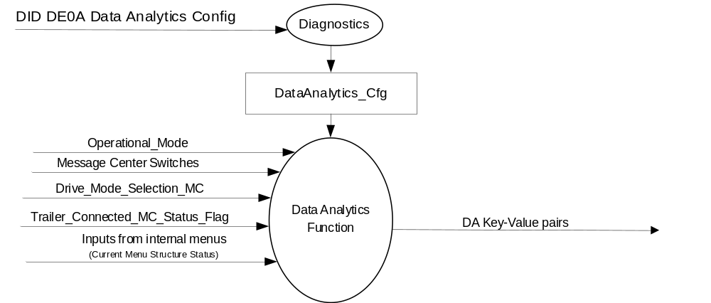

Inputs

      - INTERNAL:
- Operational_Mode
- Message Center Switches – will vary per cluster. (Examples: OK, Up, Down, Back, Folder) and Quick Action Menu Switches if Applicable (Media, Vehicle Settings, Navigation, Phone, and Home)

- Drive_Mode_Selection_MC (See Selectable Drive Mode Control Function – CGEA 1.3 STSS)
- Trailer_Connected_MC_Status_Flag (See Warning – Trailer – CGEA 1.3 STSS)
- Inputs from internal menus (Menu Structure status)

Outputs
- DA Key-Value pairs – To be further defined in Wiki pages to implement. This is the Event definiton along with the data to be logged.

Function/Performance

Operational Modes

Mode | Differentiating Vehicle Conditions
Sleep Mode | Data Analytics OFF
Limited Mode | Data Analytics ON (If transferring data to ECG)
Normal Mode | Data Analytics Logging ON
Crank Mode | Data Analytics Logging ON

Voltage Levels

Refer to the Cluster Features table located in Operational Modes and Voltage Range Strategies Section in this SPSS.

Human-Machine Interface

Visual

None

Audio

None.

System Accuracy

The Data Analytics system shall log events into RAM within 100msec as indicated in the state matrix reference 1.3.5.1 Subsystem Algorithm Flowchart/ State Diagram

Operation: Performance and Functional

Subsystem Algorithm Flowchart / State Diagram

Data Analytics Configuration

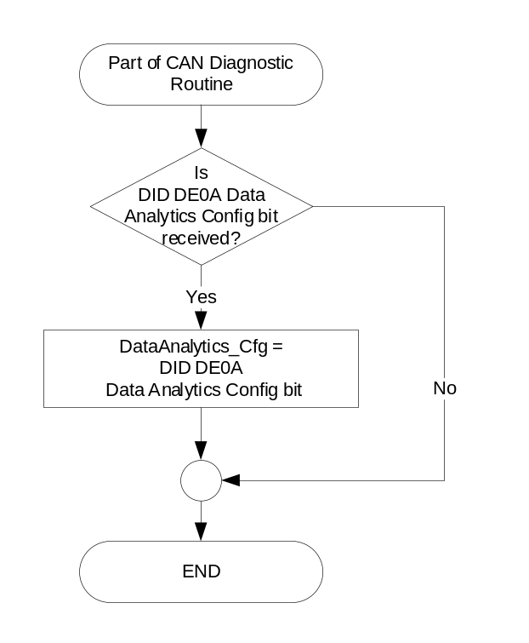

State Matrix for Data Analytics

DataAnalytics_Cfg | Expected Actions
Disabled (0x0) | No Data Analytics should be done in the cluster.
Enabled (0x1) | Data Analytics should be enabled in the cluster.

Events/Data to Log

Event | Data to Log (See Note 1) | QNX Time Stamp
Ignition Transition | Off → Run | Yes
 | Run → Off | Yes
Screen Transitions  (See Note 2) | Each screen when displayed | Yes
 | Each Screen when removed from display | Yes
Button Presses | OK Press | Yes
 | Back Press | Yes
 | Up Press | Yes
 | Down Press | Yes
 | Menu Press | Yes
SDM Transition | New SDM selected (also due to ignition off->on transition) | Yes
Trailer Connection Status Transition | Updated Trailer Connection Status | Yes
Warnings | Each Warning when displayed | Yes
 | Each Warning when no longer displayed | Yes
Control Popups | Each Control Popup when displayed | Yes
 | Each Control Popup when no longer displayed | Yes
MyView Screens | List available MyView screens each time we exit MyView setup screen | Yes
Note 1: This is a MINIMUM amount of data to log. (Supplier is encouraged to log more data)
Note 2: Ford/Supplier to agree on screens and numerical designations to pass to the ECG.

Operation Description (supports algorithm flowchart /state diagram)

High Level Assumptions
The team agreed that the cluster did not need to run any timers when on a screen. The timing information will be done by post-processing the cloud data.

- All data shall be saved in a data log. The data log format and retrieval mechanisms shall be determined by each cluster supplier working with the core data analytics team.

- All Personally Identifiable Information (PII) shall be stripped out of the log files before storage to the data log.

Function Safety Classification (EMC)

B

Memory Storage

Parameter Name | Description | Value at  Battery Connect | Value at  Module Wake-up
DataAnalytics_Cfg | Configures the cluster to determine whether the Data Analytics feature is active.  - Disabled (0x0)  - Enabled (0x1) | Use Stored Value | Use Stored Value
Operational_Mode | 4 state indicator for cluster operational mode | Limited | Limited, Normal or Crank

Prove Out

None

Reconfigurable RTT

None.

Message Center Msg

None

Error Handling

Missing Message Strategy

None

Diagnostics

Self Test

None

Engineering Test Mode

Reference section “Dealer / Engineering Test Mode (ETM)”

Part II Performance

Supported Diagnostic DIDs (Service $22)
Number | PID / CommonID Name | Bytes | DID Type | Comments
 | None

Supported Diagnostic Trouble Codes (DTCs)

DTC | Description | When Logged
None

DID DExx
Block  Num | Block Description | Size  (bits) | Type | Byte(s) | Bits | State: Description | "0" | "1" | Default | Comments/  Information
PACKETED BLOCKS
$0A | Option Content (B&A) | 1 | 1 | * | * | Data Analytics Config | Disabled | Enabled | Enabled | Allows the Data Analytics Feature. Should be Enabled for FNV2 architectures.
*Byte and bit location to be identified in Part II Specification for this cluster

Reference Specification

Revision History

SPSS Module Revision History

Revision Level | Name | Change Description | Date
1.0 | S.Watkins | Initial Release | 8/20/2018
2.0 | S. Watkins | After extensive supplier review have updated this STSS. Since there are extensive deletions from the first vesrion, they have been removed to avoid clutter. The new and/or updated sections are highlighted in yellow. | 9/16/2018

